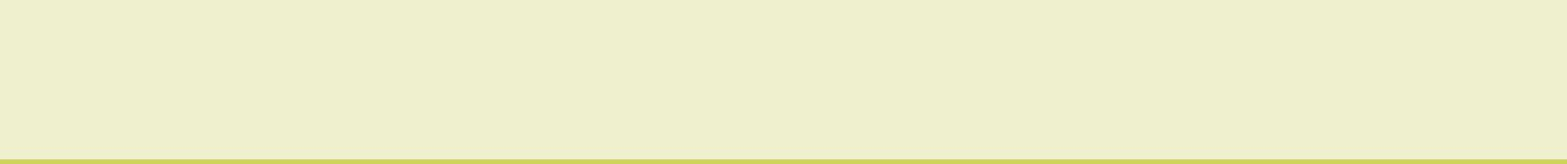
ACTIVE LEARNING TEMPLATE: Growth and Development

STUDENT NAME

DEVELOPMENTAL STAGE school Age REVIEW MODULE CHAPTER

EXPECTED GROWTH AND DEVELOPMENT
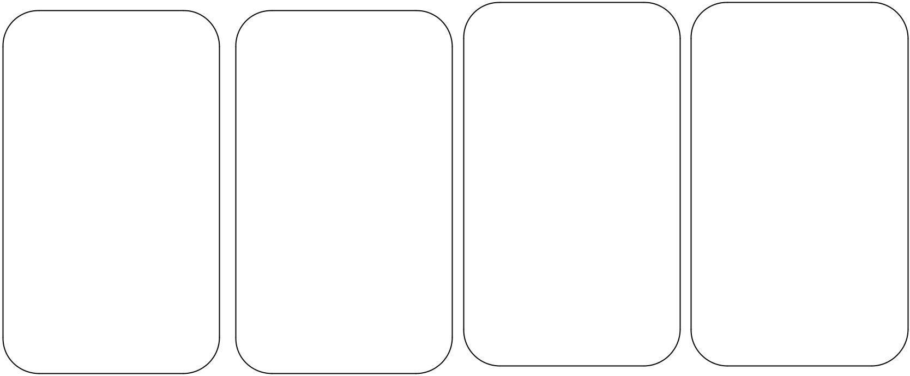

 |  |  |  |  |  |  |  |  |  |  |  |  |  | Psychological
 | Physical |  |  |  |  | Cognitive
 | Physical |  |  |  |  | Cognitive |  |  |  |  |  |  |  | Development
 | Development |  |  |  |  | Development |  |  |  |  |  |  |  | Development
 |  |  |  |  |  |  |  |  |  |  |  |  |  | The child begins to
 | The school age |  |  |  |  | School-age children's
 |  |  |  |  |  |  |  |  |  |  |  |  |  | understand desired
 | student’s physical |  |  |  |  | thinking skills
 |  |  |  |  |  |  |  |  |  |  |  |  |  | societal rules which
 | development is rather |  |  |  |  | become increasingly
 |  |  |  |  |  |  |  |  |  |  |  |  |  | include conscience
 | slow. They gain 5-8 |  |  |  |  | sophisticated as they
 |  |  |  |  |  |  |  |  |  |  |  |  |  | and morality.
 | cm in one year and |  |  |  |  | encounter new
 | Weight of 2-6kg (Snider, 2007). |  |  |  |  | people, places, and
 |  |  |  |  |  | ideas. They develop
 |  |  |  |  |  | the ability to learn in
 |  |  |  |  |  | abstract ways from
 |  |  |  |  |  | books, art, movies,
 |  |  |  |  |  | and experiences.
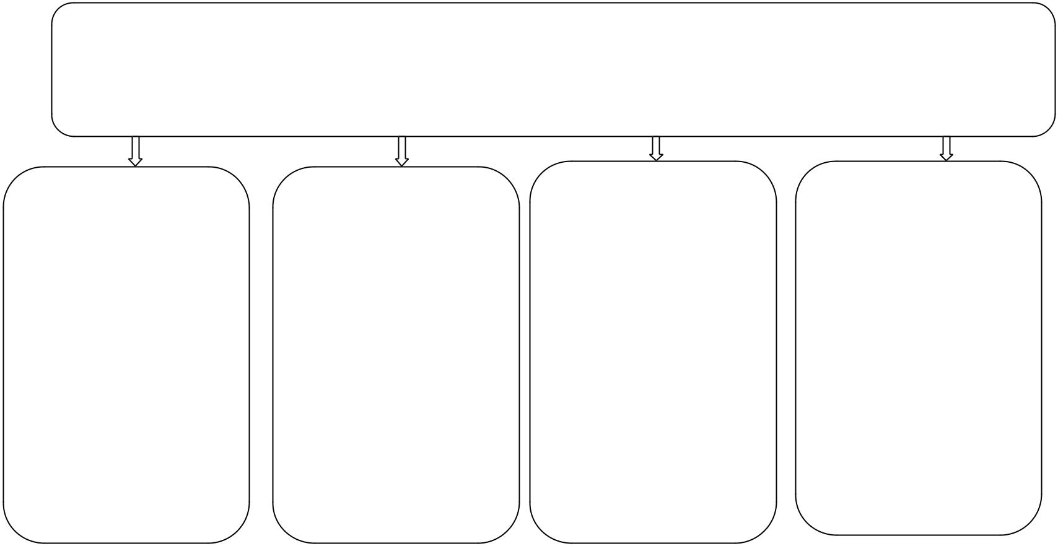

Health promotion

Age- Appropriate Activities

The most prevalent activities for the school age child is playing together with the peers of the same gender, biking and imitating the significant others.

There are indicators for health promotion which include learning disorders, scoliosis, enuresis and kyphosis at the age of school going children.

 | Immunizations |  |  |  | Health Screening
 | The recommended |  |  |  | School going
 | vaccines for the |  |  |  | children should be
 | school going children |  |  |  | screened for cervical
 | include HPV, |  |  |  | cancer, prostate
 | chickenpox, |  |  |  | cancer,
 | varicella, pertusis |  |  |  | cardiovascular
 | and varicella (Hills, 2007). |  |  |  | diseases and high
 |  |  |  |  | blood pressure.

Nutrition

There is a
requirement that at
the age of school

going the nutrition
portion of a child
should be very high
in starch. These

anticipated due to the
high rate of activity
those children

possess at this age.

Injury Prevention

There are precautions which should be kept in place to prevent children from injury. Wearing helmet while biking and field playing should be monitored by responsible adults.

ACTIVE LEARNING TEMPLATES THERAPEUTIC PROCEDURE A5

